PRODUCT REPORT- Medical Syringes

Dimah alabdulhafith

Product Report

SIDF |  Saudi Industrial Development Fund

2023

# **1.Product Information**

## Definition

Medical Syringe, categorised under drug delivery products, is a medical device that is used to inject fluid into, or withdraw fluid from, the body. A medical syringe consists of a needle attached to a hollow cylinder that is fitted with a sliding plunger. The downward movement of the plunger injects fluid; upward movement withdraws fluid. Medical syringes were once made of metal or glass and required cleaning and sterilization before they could be used again. Important considerations when purchasing a syringe include medication dose size, syringe tip, dead space and safety. Syringe size is determined by the amount of fluid or dose volume to be injected or withdrawn. Syringes are manufactured by centimeter (cc) or milliliter (ml) sizes. The larger the syringe size, the lower the flow pressure. Central line injections are usually conducted with syringes of 10 mL or higher to reduce the risk of rupturing the tubing from too much pressure.

## 1.2 Application

Medical Syringes are often used to administer injections; insert intravenous drugs into the bloodstream and apply compounds such as lubricant. Medical syringes are sometimes used without a needle for orally administering liquid medicines to young children, because the dose can be measured accurately, and it is easier to squirt the medicine into the subject's mouth instead of coaxing the subject to drink out of a measuring spoon.

* 1. Pictures

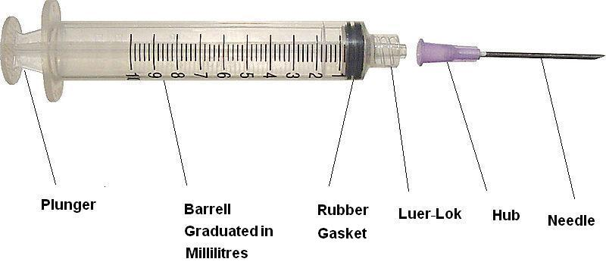

* 1. Product substitutes

There is no product substitute for medical syringes.

# **2.Market Dynamic**

## 2.1 Historical Supply/Demand

|  |  |  |  |  |
| --- | --- | --- | --- | --- |
| Medical Syringes (Unit/Year) | Installed Capacity | 2021 | 2022 | 2023 |
| Alshifa | 275,000,000 | 168,571,994 | 188,958,674 | 222,971,236 |
| Mais | 96,000,000 | 7,097,768 | 7,956,155 | 9,388,263 |
| Dawa Al-Saudia | 19,000,000 | 1,774,442 | 1,989,039 | 2347065.64 |
| Total Production | 390,000,000 | 177,444,204 | 198,903,868 | 234,706,564 |
| Imports |  | 44,361,051 | 49,725,967 | 58,676,641 |
| Local Demand | **221,805,255** | **248,629,834** | **293,383,205** |
| Growth in local Demand (%) | - | 17% | 18% |
| Exports | 7,773,081 | 10,882,314 | 15,235,240 |
| Comments: | * Majority of elective surgeries in MOH & Non-MOH sectors were postponed due to COVID-19 pandemic that resulted in sharp decrease in consumption of syringes during the pandemic, but the market recovered as of 2021. * Dawa Al-Saudia is a new entrant in the business of Drug delivery products. * All purchases by Government institutions are being made through NUPCO. | | | |
|
|
|
|  | | | | |

2.2 Future Demand/Balance

The following table shows supply & demand balance for the subject product in the Saudi Market during the next five years is as following: -

|  |  |  |  |  |  |
| --- | --- | --- | --- | --- | --- |
| Medical Syringes (Unit/Year) | | | | | |
| Year | **2024** | **2025** | **2026** | **2027** | **2028** |
| Supply | 527,360,000 | 527,360,000 | 527,360,000 | 527,360,000 | 527,360,000 |
| Demand | 322,721,526 | 354,993,678 | 390,493,046 | 429,542,350 | 472,496,585 |
| Surplus | 204,638,475 | 172,366,322 | 136,866,954 | 97,817,650 | 54,863,415 |
| Demand Growth |  | 10% | 10% | 10% | 10% |
| Comments:   * A growth rate of 10% has been considered in line with Industry study for Medical disposable. * An additional capacity of 137,360,000 Units/year of syringes from Rawand Medical Company. | | | | | |

# **Porter Five Forces**

Threat of New Entry

**-Low**

Multiple local & international producers.

Competitive Rivalry

**-High**

Multiple local producers with cheap imports originating from India & China makes this business highly competitive. The competition is severe between the imported brands and the local producers.

Power of Supplier

**-Low**

Less capital & low level of technology makes this business easy to enter

Power of

Buyer

-**High**.

Buyers’ market due to multiple producers in Kingdom

**-Low**

No real substitute for medical syringes.

Threat of Substitutes

# **4. Prices**

Medical syringe prices are not controlled by SFDA and all producers/importers are free to decide about their own price. Normally selling prices are dependent upon the price of medical grade polypropylene that is the main raw material and the quantity ordered. Higher quantities ordered by NUPCO get a better price. The average selling price during last three years and current selling prices are as follows:

|  |  |
| --- | --- |
| **Syringe Type (ml)** | **Selling Price (SR/Unit)** |
| **1 (Insulin)** | 0.22 |
| **1 (Vaccine)** | 0.41 |
| **3** | 0.135 |
| **5** | 0.15 |
| **10** | 0.24 |
| **20** | 0.35 |
| **50** | 0.90 |
| **10 (Oral syringes)** | 1.45 |

# **5. Product / Market Card**

* No real substitute to syringes at present.

Substitute Product

* Main demand driver is the domestic pharmaceutical manufacturing industry that is expected to show a good future growth due to Government focus on localization.
* Public & private sector hospitals & clinics.

* Buyers’ market as multiple suppliers in domestic & international market.

Customer Segmentation

Power of Customer

Demand Drive

Product Market Card

**6. Success Factors**

* Any potential project should have an experienced & qualified regulatory team to be aware of SFDA processes and regulations.
* Export plan for neighboring countries in GCC /MENA region.
* Qualified & experienced Marketing & Sales Manager.